Nhóm 12:

WEBSITE BÁN QUẦN ÁO TAFs

- Figma:

- Link Figma: <https://www.figma.com/design/MXlWehuu6Iq45MVD8NYYuq/Untitled?node-id=0-1&t=wXiRQWMvVZ5BXBst-1>

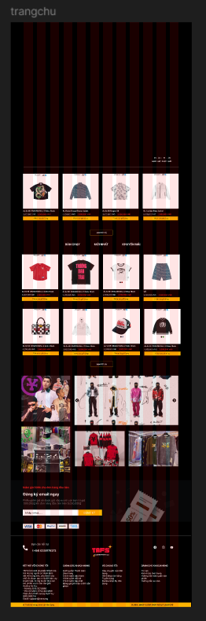

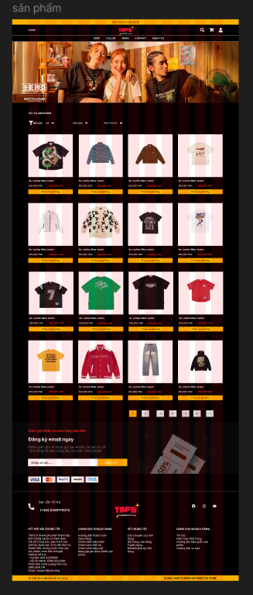

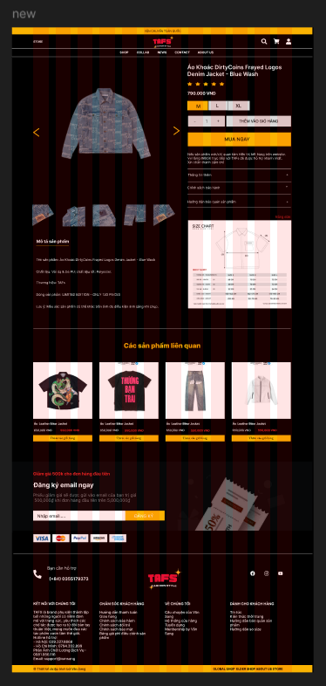

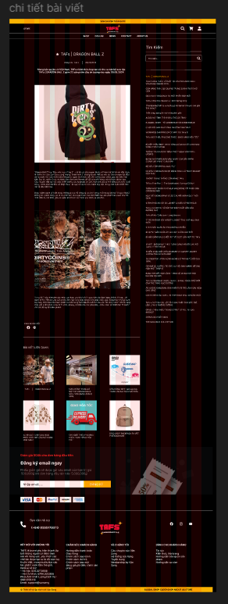

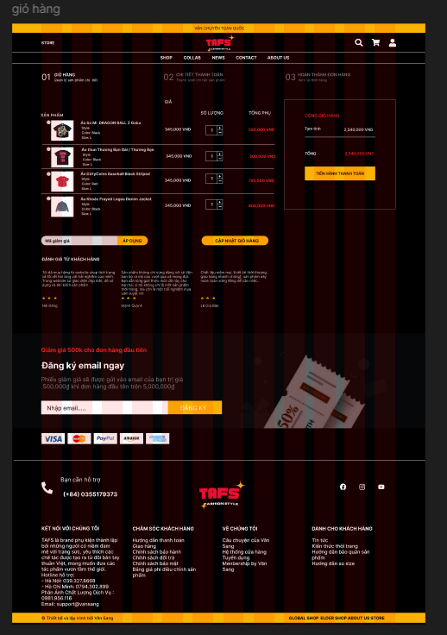

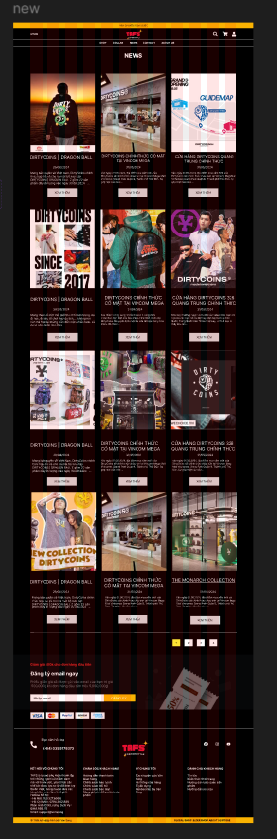

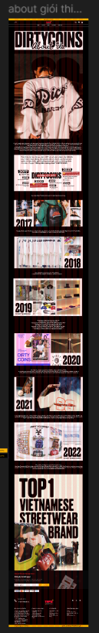

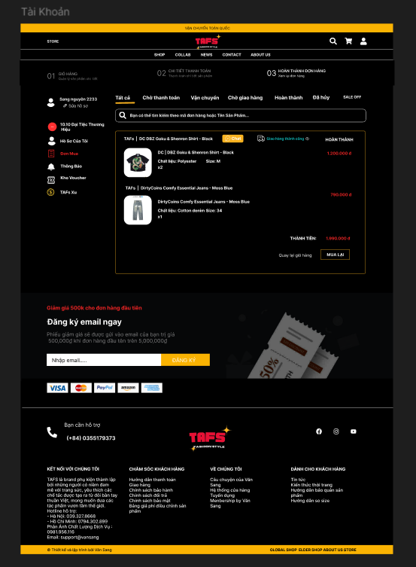



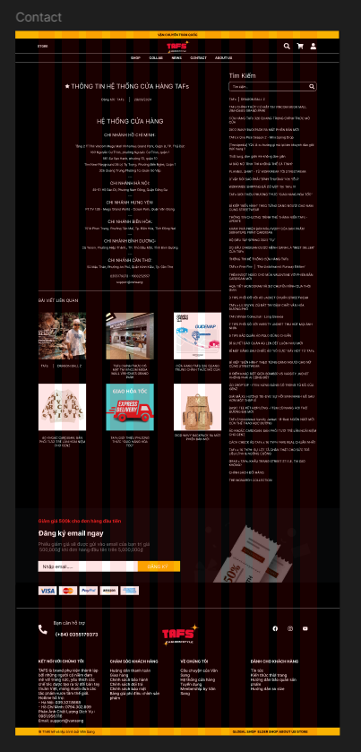

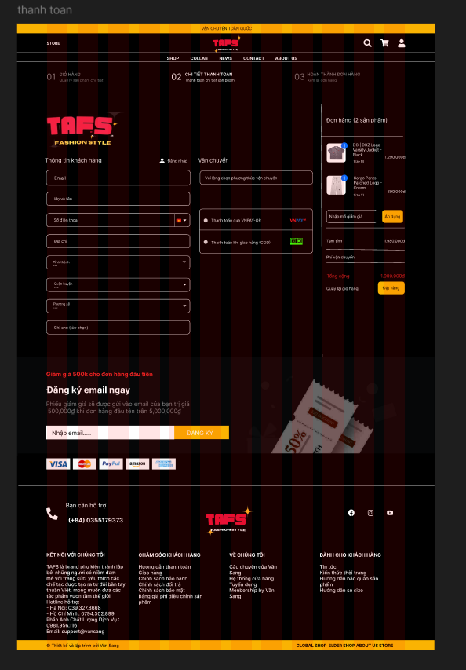



- Use case user:

- Link user:

[https://lucid.app/lucidchart/21944d70-96d0-43cb-8f58-0ea89bb8aa4d/edit?viewport_loc=-249%2C-222%2C3098%2C1433%2C0_0&invitationId=inv_0d9610d0-3a46-4ca1-a385-01f3f77c108](https://lucid.app/lucidchart/21944d70-96d0-43cb-8f58-0ea89bb8aa4d/edit?viewport_loc=-249%2C-222%2C3098%2C1433%2C0_0&invitationId=inv_0d9610d0-3a46-4ca1-a385-01f3f77c108d)

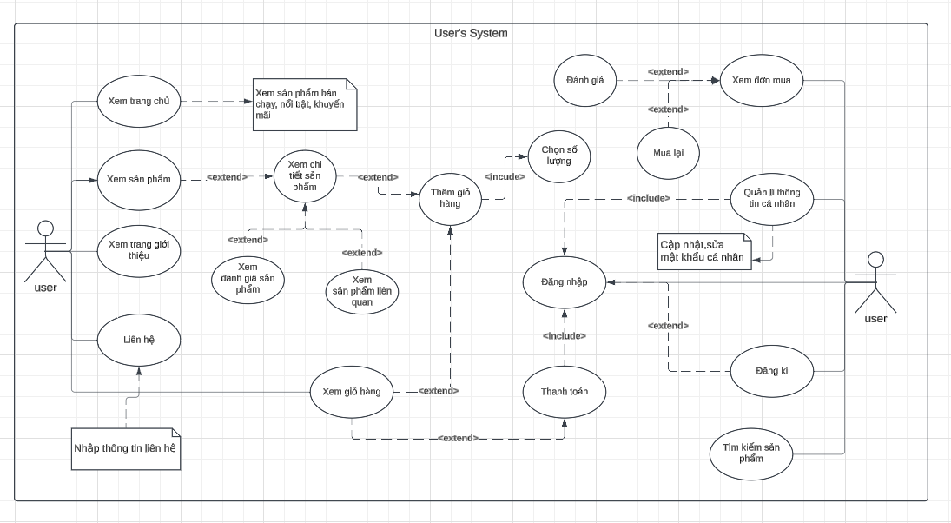

- Use case admin:

- Link admin:

<https://lucid.app/lucidchart/b10173f0-051b-4e56-b2ce-0fa2a7263f1c/edit?viewport_loc=-897%2C-698%2C2560%2C1184%2C0_0&invitationId=inv_bc6cf515-f5b8-470a-bcd5-3d53e9636d98>

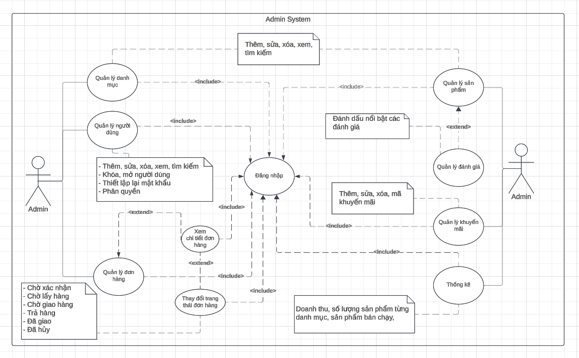

- ERD cấp 1:

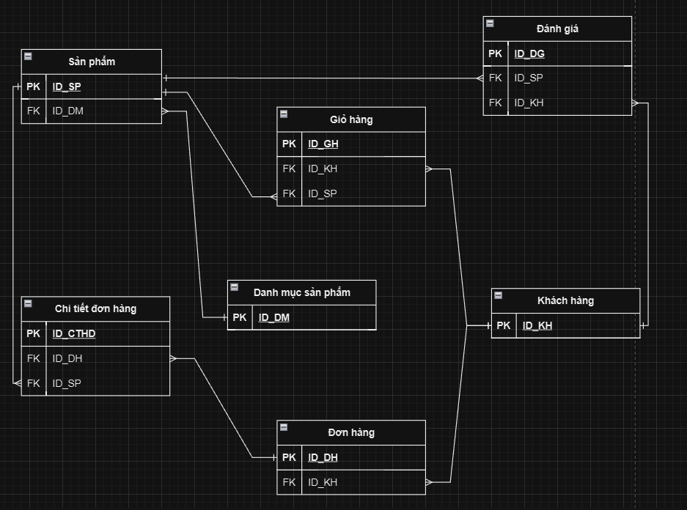

- ERD cấp 2:

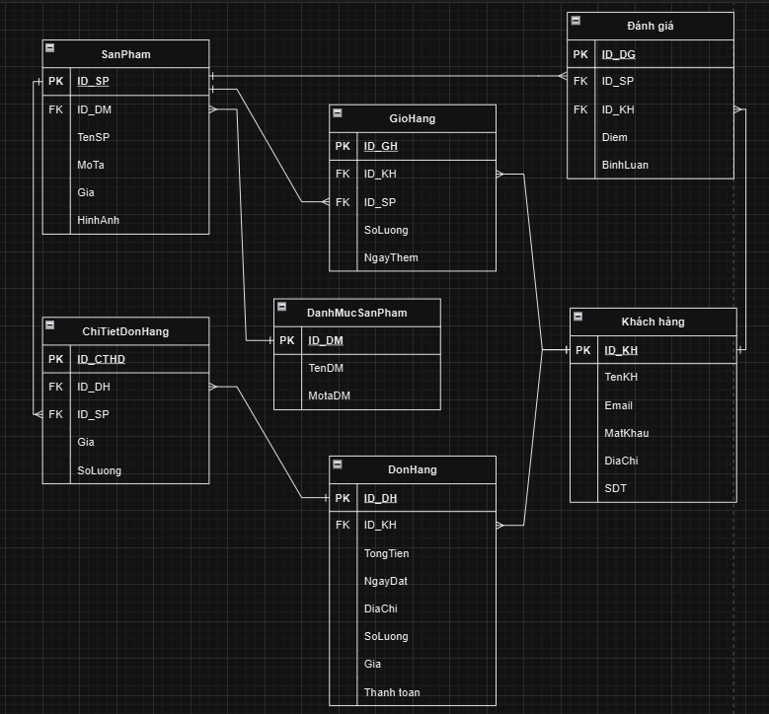

- Link ERD:

<https://drive.google.com/file/d/1Un-v0Yj00nNMdcCZV4DtOf1NoR8GjllN/view?usp=sharing>

- Sơ đồ Database:

